**USER MANUAL FOR AUTOMATIC GRADING SOFTWARE**

### 

## **I.User object**

* All users are allocated AutoGrading.exe software

## 

## 

## 

## **II.User Manual**

#### **1.Input Exam code Path.**

- Step 1 : Start the Auto Grading software.exe.

- Step 2 : Click on the button browse in line with the word test code path.

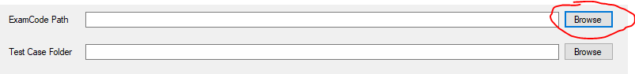  
- Step3 : Select the folder containing the test code and click to the button select folder to confirm.

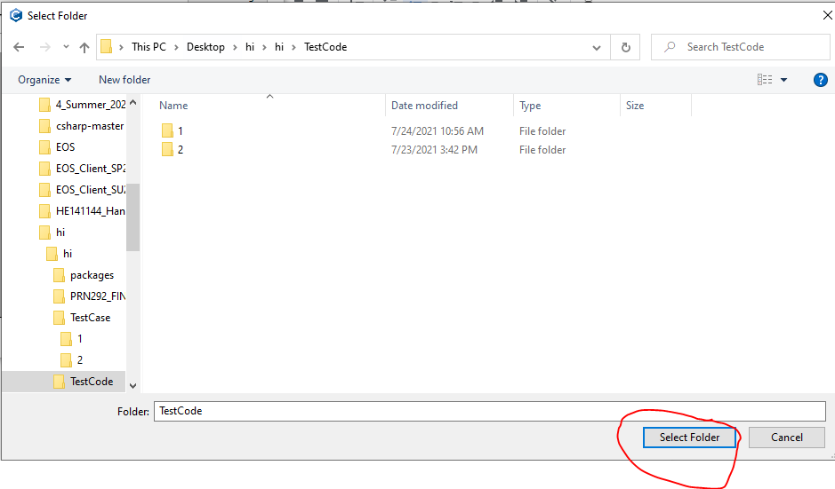

#### 

#### **2.Input TestCase Path**

- Step 1 : start the Auto Grading software.exe.

- Step 2 : Click on the button browse in line with the word test code path.

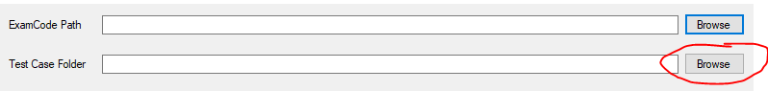  
 - Step3 : Select the folder containing the test code and click to the button select folder to confirm.



#### **3.Start Grading**

-Step 1 :Input Exam code Path .

-Step 2:Input Test Case Path .

* -Step 3: Click the Start Grading button.
* 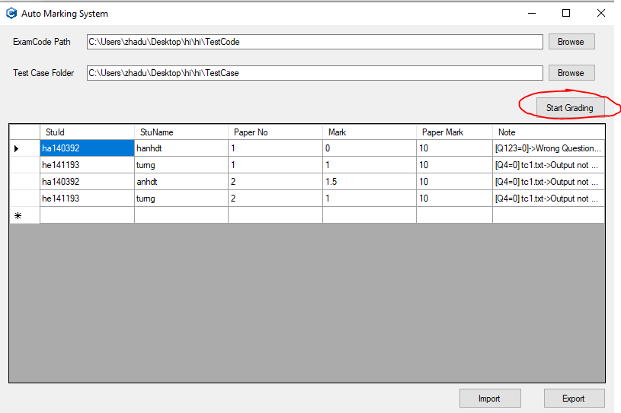

*Notice

* Code Path and Test Case path should be right to grade.
* Code Path and Test Case path can not equal.
* Step 4 : Get the result after Grade on display.

#### **4. Import Data to database**

-Step 1 :Input Exam code Path .

-Step 2:Input Test Case Path .

-Step 3: Click the Start Grading button.

-Step 4: Click the Import button to import the Result to database.

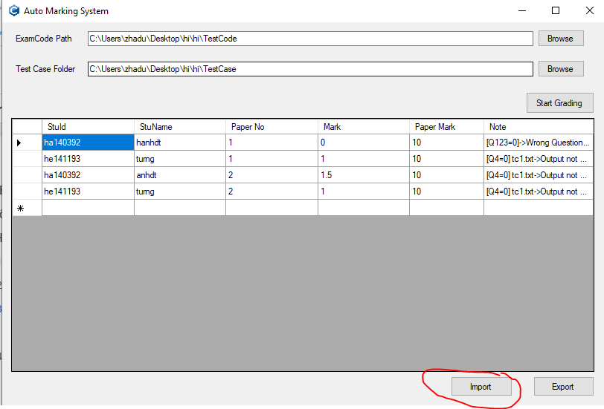

#### **5. Export Data to Excel**

-Step 1 :Input Exam code Path .

-Step 2:Input Test Case Path .

-Step 3: Click the Start Grading button.

-Step 4: Click the Import button to import the Result to the database.

-Step 5 : Click the Export button to export the Result to Excel..

